**Project Design Phase**

**Problem – Solution Fit Template**

|  |  |
| --- | --- |
| Date | 15 June 2025 |
| Team ID | LTVIP2025TMID43861 |
| Project Name | Transfer Learning-Based Classification of Poultry Diseases for Enhanced Health Management. |
| Maximum Marks | 2 Marks |

**Problem – Solution Fit Template:**

Deeply understand the needs, motivations, and barriers of poultry farmers in both rural and commercial settings.

By mapping their behaviors, constraints, root problems, and emotional triggers, we can design a solution that truly serves them.

This framework helps us align our team around the real-world challenges farmers face — enabling the creation of an AI-powered mobile tool that diagnoses poultry diseases through images and recommends timely treatments.

It ensures our solution is grounded in empathy, practicality, and local context.

**Purpose:**

* Address poultry health challenges in a way that fits the realities of rural and small-scale farmers.
* Accelerate adoption of your AI-powered solution by aligning with existing behaviors, such as using mobile phones and local communication channels.
* Strengthen outreach with clear messaging that highlights fast diagnosis, reduced bird mortality, and cost-effective treatment.
* Build trust by solving urgent and frequent issues like unidentified poultry deaths and treatment delays.
* Understand farmers’ current practices and constraints to create a meaningful, impactful solution they can rely on.

**Template:**

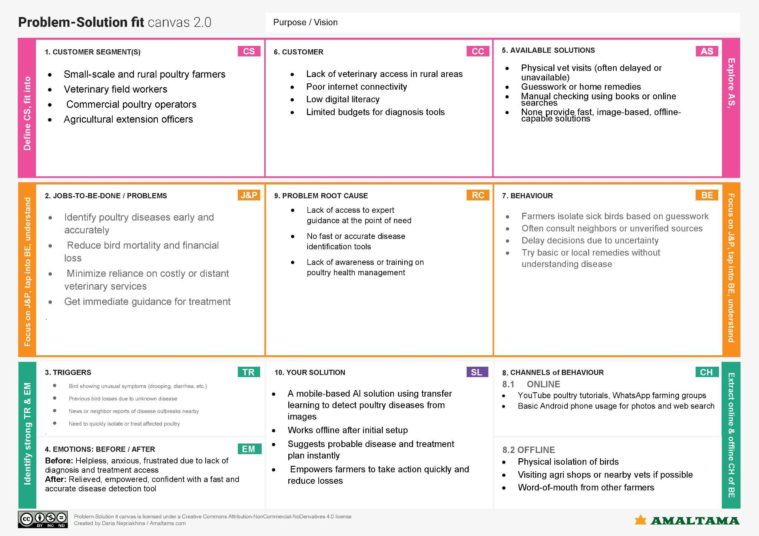

References:

1. <https://www.ideahackers.network/problem-solution-fit-canvas/>
2. <https://medium.com/@epicantus/problem-solution-fit-canvas-aa3dd59cb4fe>